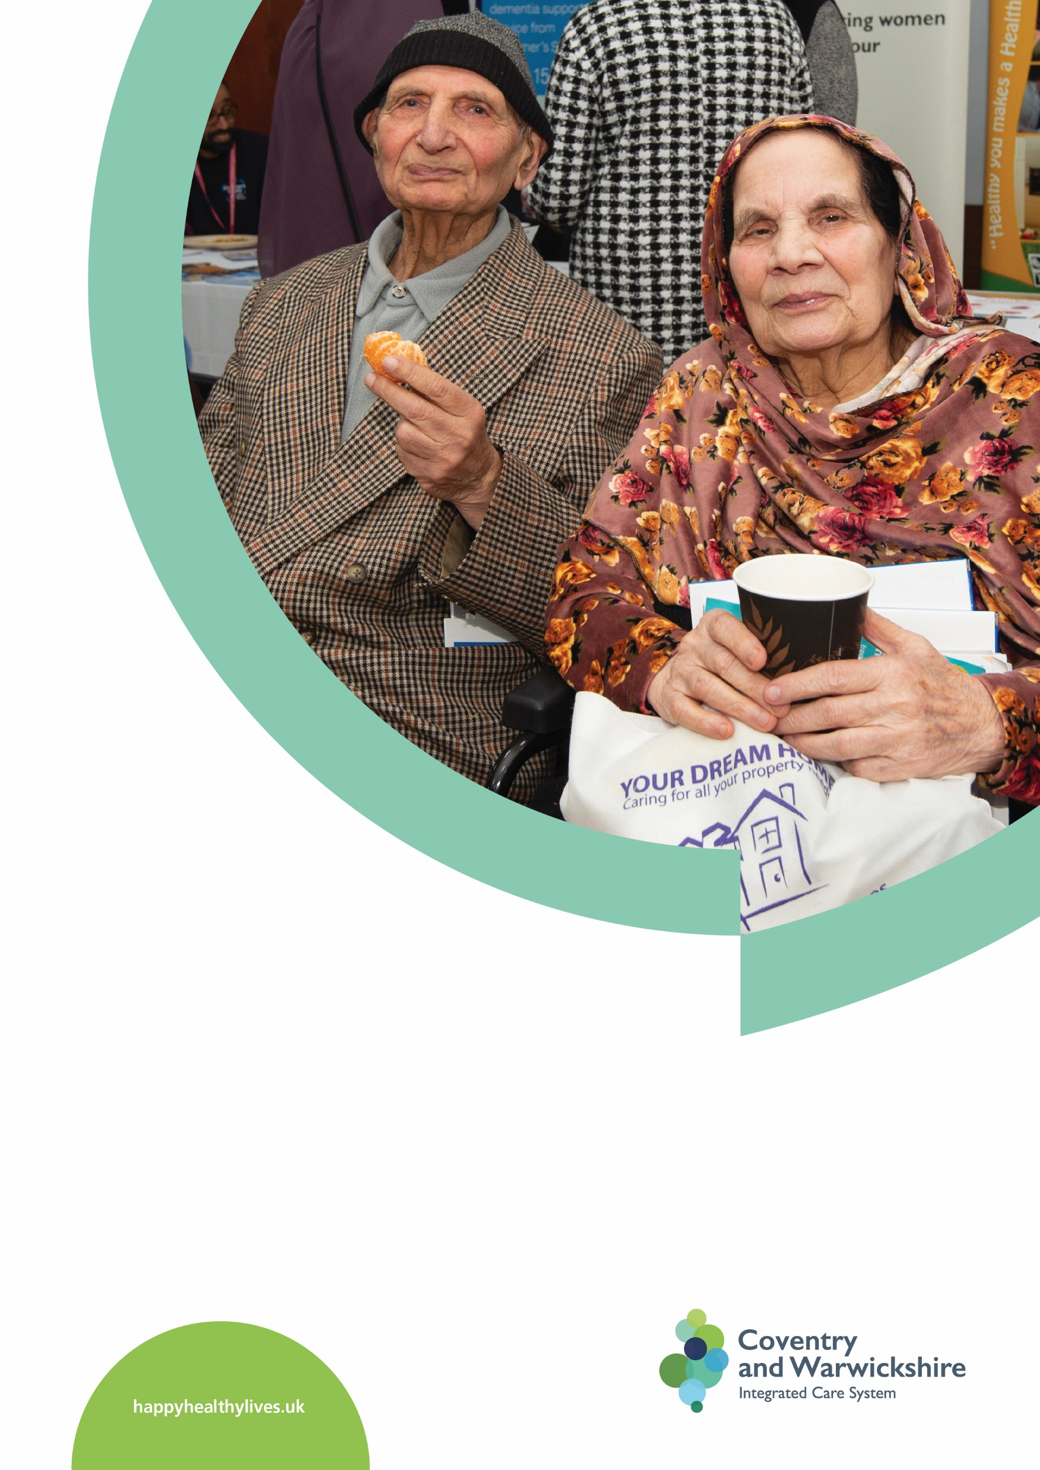
Coventry and Warwickshire Integrated Care Board –
Communities Strategy

ICB Communities Strategy
Contents
ICB Communities Strategy 2
Introduction and current position 3
Introduction 3
How we use language in this document 5
The local population 6
The partner organisations of the ICS 7
The role of involvement and cultural competency in reducing health inequalities 7
Our current position and areas for development 8
Addressing the areas for development 8
Meeting anticipated ICB legal duties on public involvement 11
Aims and principles of the strategy 13
The aims of the ICS 13
The 10 principles for engagement 14
Objectives of the strategy 14
Delivering on our objectives 15
1. Developing our involvement functions and networks 15
2. Supporting the delivery of ICB and ICP priorities for 2022-23 22
3. Individuals and communities in ICB governance and workstreams 30
Roles, responsibilities and resources 41
Roles and responsibilities 41
Resources 42
Monitoring and evaluating the strategy 42
Approach to reviewing engagement activity & impact 42
Plans for feeding back to individuals and communities 43
Appendices 44
Appendix 1 – Additional Case Studies to show Involvement in Action across the ICS 44
Appendix 2 – Delivery Timeline 47
Appendix 3 – Involvement supporting health inequalities – example methodology 48
Appendix 4 – The Healthwatch Good Engagement Charter 50

Introduction and current position

Introduction
Everyone working in health and social care in Coventry and Warwickshire has a common purpose. We want every person in Coventry and Warwickshire to start well, live well, and age well. This means enabling people to take action themselves to prevent becoming ill in the first place, to recover well, or to manage long term health needs as independently as possible.
Working together in an Integrated Care System (ICS) means listening to local people and, where needed, changing the way health and care partners work together, removing the barriers between services and joining up care around people and populations. Providing equal access to good health care and advice is one way to improve people’s health and wellbeing. The whole ICS working together also enables us to address the other factors that might affect people’s health such as housing, education and access to jobs.
Better, joined up, statutory and voluntary services should result in a system that works better for local people, reducing the complexity that currently exists which people often tell us they find difficult to navigate. Improved, more easily accessible services for communities lead to better outcomes for everyone.
But truly integrated care does not just involve organisations coming together to decide what is best for the communities we serve. A strong and effective ICS will have residents and communities at its heart, enabling people to be part of the identifying the issues and helping to find solutions in a way that works for them and meets the real priorities of local communities. The insights and diverse thinking of local people will enable us to tackle health inequalities and the other challenges faced by health and care systems.
To involve individuals and communities in a way that is both meaningful and representative will take everyone working together and a cultural shift in how ICS organisations operate. The ICS design framework sets the expectation that all partners across the system should agree how to listen consistently to, hear what is being said by and collectively act on the experience and aspirations of local people and communities. Across Coventry and Warwickshire, all partner organisations, particularly the two Local Authorities, voluntary sector and Healthwatch, have developed many examples of excellent best practice in working with communities, understanding experiences and championing co-production, and we will build on and learn from their experiences in shaping the ICS approach.
Despite that rich understanding held by all partners, we have not always historically worked together as a system to engage local people, instead relying on individual organisational networks. COVID-19 changed this and showed what we could do without organisational barriers, working together with one another, local Healthwatch organisations, partners in the Voluntary, Community and Social Enterprise sector and the population of Coventry and Warwickshire. Developing our learning from this and from the excellent work already being undertaken by all ICS partners in involvement will allow us to build on existing relationships, networks and activities and develop a strategy with and for individuals and communities. This strategy will lay the groundwork for how we work together as a system and how we share and develop new ways to develop two-way communication with the diverse communities that make up Coventry and Warwickshire, engaging and involving local people on their terms and in a way that works for them.
This strategy covers how the partner organisations of the Coventry and Warwickshire Integrated Care System will develop our approach to creating a framework for working together and how we will decide what engagement should happen at Place, Primary Care Network Level and System, sharing insights to enable a broader and better understanding of what is important and makes the biggest difference to individual communities. It also covers how involvement will support the priorities of the ICB and the ICP as they become established. Finally, it outlines the involvement mechanisms currently in place and how we will embed involvement throughout the ICB, developing the cultural competency to understand what people tell us and use that insight to reduce health inequalities and improve health and wellbeing.
This document is only the preliminary draft of our Strategy. Throughout 2022/23 we will engage with the people who live and work in Coventry and Warwickshire, stakeholders and our workforce to develop the strategy further and ensure that our objectives, methodology and goals are the right ones for everyone and delivered in the right way, with and for local communities.

How we use language in this document
Part of Cultural Competency is how we use language in our own documents to refer to people and diverse communities. The NHS Race and Health Observatory have developed a set of five principles to follow when writing and talking about race and ethnicity. We will adopt these principles, not only within this document but through all our involvement work.
Be specific - We will always be as specific as possible about who we’re talking about. Collective terminology should never be used for convenience or to save time. We will be clear in our conclusions and our recommendations about who we are really talking about, and we will require all organisations we commission to disaggregate findings by ethnic group.
No acronyms or initialisms - We will never use acronyms, initialisms or other contractions to refer to groups of human beings. Contractions like ‘BME’ and ‘BAME’ create a further level of needless abstraction from the communities and individuals we are talking and writing about.
Context - We will only use collective terminology where we absolutely must. And even where collective terminology is required, we will always be guided by context and will not adopt a single blanket term. We will always challenge ourselves to think specifically about what we are trying to say. In practice, this means that you will see the terms ‘Black and Asian’, ‘Black and minority ethnic’, ‘ethnic minority’, ‘Black, Asian and ethnic minority’ and ‘people who experience ethnic health inequalities’ depending on the context and the content of the work reported on. Where the context is not decisive, we will use the above collective terms interchangeably. This is to reflect the fact that no one term suits everyone and to pursue our objective of respecting individual and community dignity. As above, even where we do use these terms, we will not use acronyms or initialisms.
Transparency - We will always be up front and open about the approach we have taken to language. We will link to the NHS Race and Health Observatory report and display these principles on our website, and we will include explanatory text in all our documents and reports to explain our approach to language.
Adaptability - We accept that language develops and that a term that is acceptable today may not be in a few months’ time. We will not draw a line under these considerations, and we will always welcome productive challenge around our approach to language and the rest of the work we do. We will change and adapt our language over time to ensure that our work remains relevant to our stakeholders.
You can find out more about the NHS Race and Health Observatory and the research that led to the development of these principles here - NHS Race & Health Observatory Terminology Consultation Report

The local population
Our new Integrated Care System will cover the footprint of our Coventry and Warwickshire Sustainability and Transformation Partnership. This footprint is home to a population of approximately 1.02m and covers two Local Authorities (Coventry and Warwickshire), and five Districts and Boroughs. It is served by three acute hospitals, two community service providers and one mental health trust, as well as 19 Primary Care Networks and 119 General Practices. There is also a thriving third sector and a diverse range of community organisations reflecting our population, as well as independent providers which make up the provider landscape.
This area is hugely diverse area, with many different communities. The below infographic demonstrates a small part of that diversity and the related need for services to be designed in a way which is culturally competent and not “one size fits all”
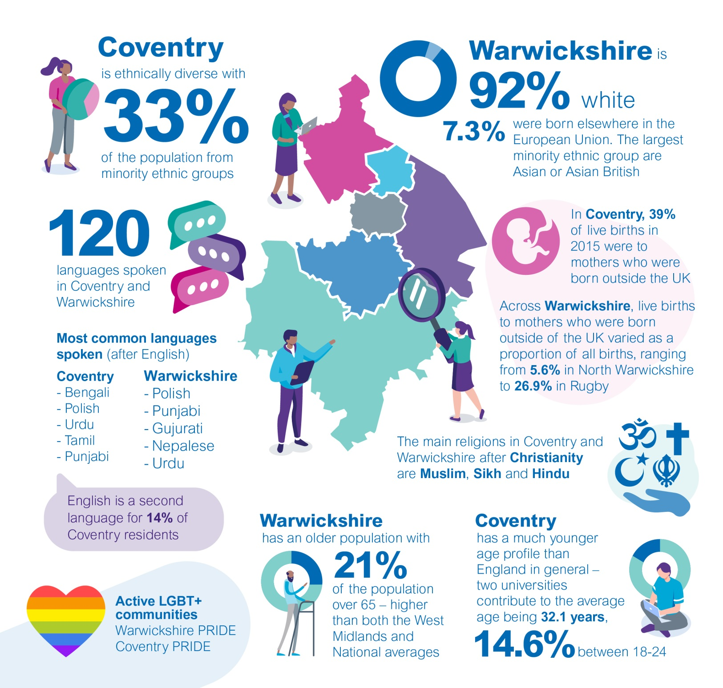

The partner organisations of the ICS
- Coventry and Warwickshire Integrated Care Board
- Coventry City Council
- Warwickshire City Council
- Coventry and Warwickshire Partnership NHS Trust
- George Eliot Hospital NHS Trust
- South Warwickshire NHS Foundation Trust
- University Hospitals of Coventry and Warwickshire NHS Trust

The role of involvement and cultural competency in reducing health inequalities
Throughout this document you will see reference to “cultural competency”, the ability to understand and interact effectively with people from diverse cultures. Improving our cultural competency is at the heart of our drive to reduce inequalities, and to develop services based on respect and appreciation of the cultural context of an individual’s life.
We are fortunate that Coventry and Warwickshire is home to multicultural and diverse communities that can help us shape the future of the health and care system. We know a person’s culture influences how they may want to access health and social care services and the kind of treatment options they are comfortable with. We must develop a greater understanding around managing language barriers, values and beliefs and/or basic dietary requirements within certain communities and gain a level of understanding in relation to health literacy within the local population. Without the cultural competency to understand the values and aspirations of our local communities, we are unable to ensure that the services we design and deliver meet individual social, cultural and linguistic needs. Furthermore, without the cultural competence to engage and collaborate with diverse communities in a way that is appropriate to them, we cannot build a true picture of how they feel about their local services and the experiences they have. Developing cultural competence is vital if we are to reduce health inequalities and ensure that health and care provision is high quality, safe and effective.
Collectively, we need to better understand and respond to communities when they tell us about their culture. We must put aside any assumptions and stereotypes which may influence how we perceive them and be aware of our own biases, even when they are unconscious, and actively work to eliminate them from our design and delivery of care. From rural villages to towns and suburbs to vibrant inner-city districts, from different faiths to diverse ethnicities, every part of Coventry and Warwickshire has their own cultures and communities which we need to learn from.
We must also recognise that within communities there may well be differences in how individual members of that community respond to engagement on health care, for example due to generational or gender differences, and so our engagement work must reflect this. There are countless opportunities for community engagement and collaboration, but we need a commitment from everyone who works in the system to actively seek and respond to ideas and feedback so we can constantly strive to improve.
The role of involvement is vital in building the mutual links with local communities that are needed to enable us to listen and understand when people tell us their priorities and to collaborate with people on solutions. Inclusivity will inform the methods of communication we deliver and how, as system partners, we can support communities to be in control of their own health and health outcomes, prioritising prevention in the way that works for individuals and making sure we are clear in communicating what services and support is available. Ultimately, working together as an Integrated Care System, alongside the people we are here to serve, will help to reduce health inequalities and improve the health and wellbeing of the population.

Our current position and areas for development
Our approach in responding to the pandemic and delivering the vaccination programme has shown us that when we work together, without barriers between local authorities, NHS providers and commissioners and communities, we can better support and respond to the needs of local residents and extend our reach much wider and deeper into local communities, particularly those who may have been excluded in the past.
Throughout the strategy you can see case studies from across the partners of the ICS which demonstrate the breadth and depth of activity that already takes place. These activities give us a strong foundation to build upon when designing how we work together as a system and better collaborate and engage with both individuals and communities.
However, there remains barriers to delivering engagement, both as a system and at local Place and Neighbourhood level, which this strategy aims to eradicate as we begin to work as one whole system.

Addressing the areas for development

Working together as ICS partners to deliver involvement and engagement
As demonstrated above, each organisation within the ICS retains its own strong community links and relationships. There is considerable innovation across the system as well as successful models for involvement in our Place-Based Partnerships. We need to build on these areas of good practice to establish a consistent and meaningful approach to involvement and engagement across the ICS.
Historically, although organisations have collaborated successfully on individual service transformation and design projects, there is no overall system approach to involvement and engagement, and no mechanism for sharing insight between organisations outside of on an individual project basis. There is also no formal co-ordination between organisations of engagement schedules, leading to some communities being approached multiple times to share their views on similar issues and consequently develop engagement fatigue and a lack of interest in working with statutory organisations.
Often, as organisations we engage when we need input rather than doing this routinely and creating a culture of always listening. We must also acknowledge that we aren’t always the right people to do the engagement. Sometimes, the best engagement takes place through those already in direct contact with residents/communities as part of daily interaction and any approach must build on this knowledge.

Involving local people and communities
COVID-19 has brought about rapid change in how we deliver our engagement and involvement. Avenues which were previously open to us in engaging local communities, such as outreach at face-to-face community events or holding drop-in sessions in local community venues, were paused and are, at time of writing, only tentatively beginning to start again. Engagement has moved primarily online and those unable to use digital services have become more isolated from our work and are at risk of being left behind.
In some cases, this has led to positive questioning of the efficacy of generic one-size-fits-all engagement in truly connecting with priority groups. Through thinking differently about engagement avenues, we have been able to use different tools to engage with people to reflect the move away from more scattergun approaches and traditional town hall events.
However, the pandemic has also thrown into sharp relief the issues and barriers felt across our ICS when trying to involve communities. Although there are positive connections with many diverse groups and excellent work taking place, we still have further to go. As part of the work to develop this strategy, individual partner organisations, as well as the two local Healthwatch organisations, compiled the following list of themes from recent insight work which address the main four areas for development:
Changing how we do things  - Lack of priority for engagement and involvement given in organisations  - Poor communication and connectivity between the NHS and Local Authorities and service users/communities leads to fragmentation of engagement activity and lack of clarity of purpose  - Top-down approach adopted by the NHS and mainstream institutions is unwelcomed by the community | Trust  - Uneven responses from local people, for example men often being underrepresented or hearing from the same groups of people, means that some groups can feel marginalised  - Lack of trust in the NHS/social care and partner organisations  - Desire to see more targeted engagement with key population groups across the ICS.  - Duplication between organisations with some groups being “over-engaged” and others feeling ignored
Improving our methodology  - Perceived lack of skills and tools available to communicate and connect with communities in diverse settings  - Lack of awareness of best practice methodologies for effective engagement with seldom heard and faith communities  - Lack of awareness or recognition within our organisations around the value of community assets to help shape local priorities and solutions, leading to a deficit- or needs-based approach | Maintaining our relationships  - Past poor involvement of communities in service planning, monitoring and management, leading to a cynicism around the point of being involved and lack of belief in it making a difference  - Desire for more community discussion groups and forums  - Requests for the recruitment of more health champions/ambassadors

This feedback is an excellent starting point. These issues will be best tackled through co-ordination at a system level, rather than through individual organisations as the issues highlighted are likely to cross all service providers.

Involving the Voluntary, Community and Social Enterprise Sector
A key aspect of involving communities that are most impacted by health inequalities will be working through, and with, the local voluntary, community and social enterprise sector, particularly the community or “grass roots” organisations, defined as those with a turnover of less that £10,000 per annum. These groups are at the heart of their communities, often supporting people who are unable to access health and care services through current routes.
Local communities will benefit greatly from the inclusion of these groups on both strategic and local planning, as they will often be better placed to understand these issues at a local and hyper-local level and share their own experiences of tackling them that can be used across the system. This will shape services to fit the priorities of diverse communities and contribute to improved outcomes and access. There is increasing awareness of the value and influence of social action versus more traditional volunteering, the former being more informal and unstructured but also flexible and dynamic, and it was of huge benefit during the Pandemic allowing for an almost instant response to changing local priorities.
Historically, statutory organisations have asked a lot from local community groups, without always considering what we might offer in return. To develop meaningful relationships this can no longer be seen as a one-way street for support. Before we ask any more from these groups, we must first understand how we can better support them to deliver their services to their communities and how they can better access funding and resources to participate.
The partner organisations of the ICS are Anchor institutions and as large local institutions they have an opportunity to support training, employment and professional development for the people of Coventry and Warwickshire. Supporting volunteers and the wider organisations who support them is a key part of this work. Supporting third sector participation will also allow us to assist them to improve their offer to their communities both through opportunities to access training for staff and volunteers, and by supporting with the development of policies and procedures.
To make this engagement meaningful, developing this structure at a Place and Neighbourhood level will be key to success as the priorities of many groups and communities are likely to be linked to individual areas, rather than operating at a system level.

Meeting anticipated ICB legal duties on public involvement
Involving the local population is, as evidenced above, the right thing to do, it reduces health inequalities and allows us to develop and deliver better services. However, as a statutory organisation, the ICB will also be bound by legal duties to involve:
NHS Constitution – places a statutory duty on NHS bodies and explains a number of rights and responsibilities which are a legal entitlement, protected by law. One of these rights is the right to be involved directly or through representatives:
- In the planning of healthcare services
- In the development and consideration of proposals for changes in the way those services are provided
- In the decisions to be made affecting the operation of those services.
Health and Social Care Act 2012 and 2021 – Within Coventry and Warwickshire ICS, all NHS partners have legal duties to involve the public in their decision-making about NHS services. These requirements are deliberately placed upon organisations to reinforce the importance and positive impact of ‘public involvement’.
The main duties on NHS bodies to make arrangements to involve the public are set out under sections 14Z44 (for NHS Coventry and Warwickshire ICB) and section 242 (for NHS trusts) of the National Health Service Act 2006 (as amended by the Health and Social Care Act 2012). Additionally, NHS Coventry and Warwickshire ICB includes, within its constitution, details about the arrangements for public involvement and links to this strategy, which outlines the principles to be followed in implementing them.

These ‘public involvement’ duties have applied to commissioners and providers for many years and are largely unchanged. However, a significant change proposed in the Health and Care Act 2021 is that the description of people to be involved has been extended from ‘individuals to whom the services are being or may be provided’ to also include ‘their carers and representatives (if any)’. While it is already common practice to involve carers and their representatives, and to do so is in line with previous statutory guidance on the public involvement duties, this change makes it a legal requirement for arrangements for public involvement to secure the involvement of carers and representatives (if any), as well as service users themselves.
The legislation does not include a definition of carers or representatives at time of writing; however, we consider relevant carers[1] and representatives should be identified by reference to the individuals who use, or may use, the services in question. It is up to local organisations to identify who to involve – depending upon the circumstances, nature of the services and decision-making process in question – but relevant carers and representatives could include individual patients’ advocates or family members who help organise their care, as well as councillors and community leaders, VCSE sector organisations, local Healthwatch and other organisations able to represent the interests of the individuals who use, or may use, the services in question. A stakeholder analysis can help determine which groups are relevant representatives depending on the context.
The ICB and local NHS trusts are also subject to the new ‘triple aim’ duty (sections 14Z43 and 26A respectively). This requires these bodies to have regard to the ‘triple aim’ of better health and wellbeing for everyone, better quality of health services for all individuals and sustainable use of NHS resources. Effective working with local people and communities will be essential to understand local populations and deliver this triple aim.

The Public Sector Equality Duty – The Equality Act 2010 – The Equality Act 2010 promotes fair treatment of people regardless of any protected characteristic they may have. All our communications and involvement activities will take this into account, paying due regard to those people with protected characteristics and ensuring equitable opportunity to be involved.

Aims and principles of the strategy

The aims of the ICS
- Improve outcomes in population health and healthcare
- Tackle inequalities in outcomes, experience and access
- Enhance productivity and value for money
- Help the NHS support broader social and economic development.
Successful involvement of the people of Coventry and Warwickshire and local communities is integral to the success of these aims
- To design and deliver effective services which are value for money, we must have a deep understanding of the priorities of the individuals and communities who use them.
- The insights and diverse thinking of individuals and communities are essential to enabling us to tackle health inequalities and the other challenges faced across the health and care system.
- The creation of statutory ICS arrangements brings fresh opportunities to strengthen our wider work with communities, building on existing relationships, networks and activities and supporting broader social and economic development.
We are not starting from scratch. The two local Health and Wellbeing Boards have developed Health and Wellbeing Strategies which outline how they we to work with communities and this work will form a significant part of the development of our approach.
The ICS has agreed a vision for our system, which explicitly highlights the importance of involvement, seeking and acting on feedback from both local people and staff.
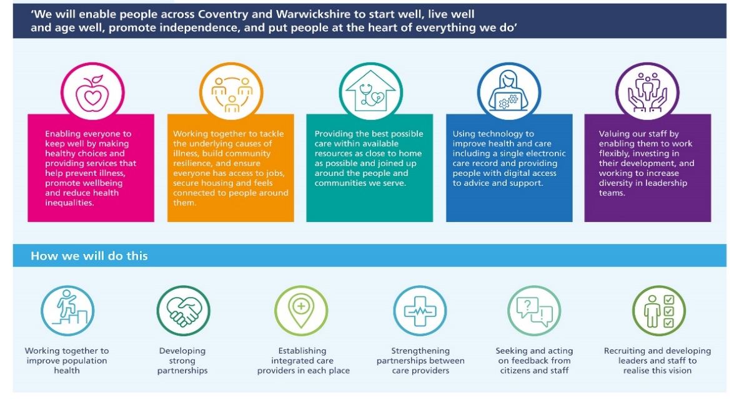

The 10 principles for engagement
In September 2021 NHS England published implementation guidance for ICSs on working with people and communities. This set out 10 principles, developed through work with systems, and designed to be a golden thread running throughout the ICS, whether activity takes place within neighbourhoods, in Places or across whole system geographies.
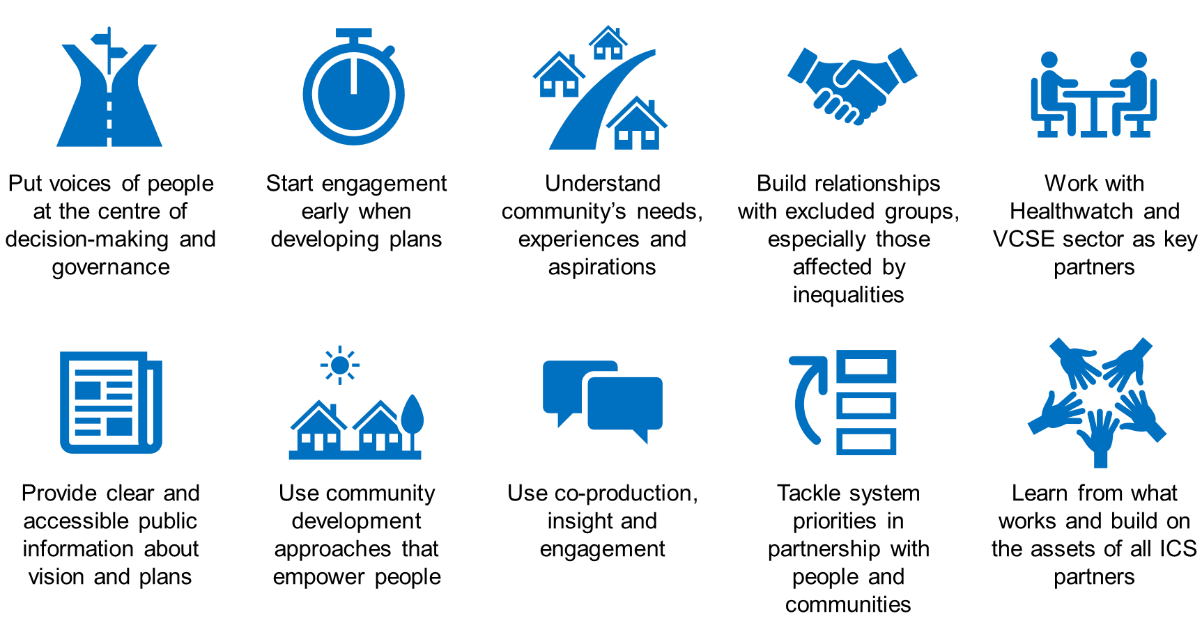
In addition to these principles, our local Healthwatch organisations have worked together to develop a “Good Engagement Charter” which echoes the principles outlined by NHS England above and provides us with a mechanism for assessing our engagement and involvement activities.

Objectives of the strategy
This strategy outlines how we will work together as partner organisations of the Integrated Care System to develop the mechanisms through which we can build trust with local people, how we involve them in the development of the right services for them and giving them confidence to use them, how we enable the services we design and deliver to be culturally competent, and how we reduce health inequalities and improve health and wellbeing across Coventry and Warwickshire.
To do this, we’ve identified three key objectives which align to the aims of the ICS and the wider vision.
- To develop our involvement functions and networks across the ICS to support the delivery of the ICS vision and become a system where working collaboratively with each other and the local population is the default
- To support the ICB and ICP to deliver on their priorities
- To continue to develop the current routes of involvement of individuals and communities in our governance and workstreams, based on the 10 principles for involvement and identify the areas for further growth and associated actions

Delivering on our objectives

Developing our involvement functions and networks
To support the delivery of the Coventry and Warwickshire ICS vision and deliver involvement against the ten principles we must address the current areas for development for involvement outlined in section one and develop ways of working together as an ICS.
To take this objective forward, a working group has been formed with the involvement leads from local authorities and health organisations, in addition to representatives from both Healthwatch organisations. This group has agreed to drive the work forward collaboratively to ensure that all partners organisations of the ICS (and wider) are represented.
Through the working group, we will establish a framework for how we work together.
To start this process, we established what our vision and aims are for involvement as an Integrated Care System. These will then define how we will come together as individual organisations and work as partners to involve local people and community groups.

Our vision
“To work together to make our health and care system work for everyone”

Our mission statement
As partner organisations in the Integrated Care System, we believe in working together with the population of Coventry and Warwickshire, and each other, building relationships that are honest, open, realistic, and transparent – but also optimistic, positive, and collaborative.
When health care services are suitable for local diverse communities, we know that inequality will be reduced, but that can’t happen without bringing the communities’ voices and experiences into the heart of organisational decision-making and design and delivery of services. We must put people at the heart of everything we do because we know that outcomes are better when they are designed in partnership.
Truly putting people at the heart of everything we do is easy to say, but hard to do in practice. It will require innovation, bravery and a cultural shift within all ICS organisations to change how things are done, involving everyone from senior leaders to commissioners and planners to frontline health and social care staff. We must develop a shared understanding of what good involvement looks like for our ICS and equip staff, stakeholders and the local population with the skills needed to participate, lead change, and flourish.
Having the right structures to support involvement is not enough and there is much work to be done to build trust amongst local communities, some of whom have felt ignored or marginalised in the past. To understand what matters most to people and what will have the biggest impact on their lives, we must develop an “always listening and learning” environment where people can share their experiences and needs with us at any time, not just when we decide we want to talk to them. When we have gathered insight, we must share knowledge between partners so individuals only have to tell their story once and we reduce the burden of involvement which falls on some communities. When we do improve things, we need to continually demonstrate the difference that community involvement has made, to show the population the value of their contributions and to champion the benefits of involvement to both local communities and the staff who work with them.
When we get it right we will unlock the local expertise of residents in order to redress inequalities and genuinely level-up outcomes for all communities. We will build trust so people feel they can share their experiences, telling us what is working and where we need to improve. When people feel involved and listened to, not only will they access our improved services but feel empowered to take control of their own health and wellbeing. Ultimately this will help people across Coventry and Warwickshire to start well, live well and age well, regardless of their background or circumstance.

Critical actions to deliver the objective
To deliver against our mission and the aims of the ICS, the following actions must be delivered
- Develop a framework for how we work together as partner organisations within the ICS
- Promote cultural change across the ICS to put people at the heart of everything we do
- Build trust and relationships through always listening and learning
- Equip everyone with the tools they need
- Demonstrate the difference that community involvement makes

The first three areas will be our initial focus of delivery, delivering the building blocks to achieve the third and fourth actions.

The ICS Vision | We will enable people across Coventry and Warwickshire to start well, live well and age well, promote independence, and put people at the heart of everything we do
Our vision for involvement | We will work together to make our health and care system work for everyone
How we will do this | Promote cultural change across the ICS to put people at the heart of everything we do | Build trust and relationships through always listening and learning | Equip everyone with the tools they need | Demonstrate the difference that community involvement makes

Action – 1. Developing a framework to support how we work together
As outlined above, it is imperative we understand what engagement happens where and who delivers that engagement so we can reduce duplication and build positive relationships with communities through those networks, organisations or individuals who are best placed to support them.
A great benefit of becoming an ICS is that the development of two Care Collaboratives (our local Place-Based Partnerships) and four Places means that decision making will be happening at a more local level, focusing on local community priorities. This means people can input on issues that are directly relevant to them and there will be more opportunity to build trust and for organisations to clearly demonstrate the difference their involvement makes.
Although at time of writing the legislation is not in yet in place, it is anticipated that the statutory duty for involvement in health care service change and development will transfer from the current Clinical Commissioning Group to the ICB. There will also be no change in the statutory obligations of local authorities to involve people in service change.
This means that, as an ICS, we must agree a framework, set of principles or other mechanism that supports how we work together and allows us to define what good involvement looks like in Coventry and Warwickshire for the benefit of local communities. It also will reflect that the majority of work will happen at Place and Neighbourhood level as well as providing assurance to the statutory organisations that the legal duties around involvement have been delivered appropriately, while also allowing the individual organisations, Care Collaboratives and Places the freedom to do things in ways that are tailored to the diverse communities they serve and directly address their priorities.
This framework will build on the good practice and knowledge already built through the work of the partner organisations of the ICS. It must be developed in conjunction with local communities and our workforce and support all ICS partner organisations to ensure best practice involvement throughout all their activities. As the framework must address the statutory requirements outlined in the Health and Care Act, its scope will be assuring and supporting Health and Care involvement, however it will need to recognise that involvement of individuals and communities can often range much more widely than single topics and cover a much wider variety of topics of interest to the community.
Across Coventry and Warwickshire there is already work in place to develop engagement routes and approaches at a Place level which will inform the System framework and what good looks like for communities.

Key deliverables and activities for Year 1
- Engagement programme to develop what good looks like with communities, avoiding duplication with Place based work
- Framework / Set of Principles for Health and Care Public Involvement in Coventry and Warwickshire

Action – 2. Promote cultural change across the ICS to put people at the heart of everything we do
Truly putting people at the heart of everything we do is easy to say, but hard to do in practice. It will require innovation, bravery and a cultural shift within all ICS organisations to change how things are done, involving everyone from senior leaders to commissioners and planners to frontline health and social care staff.
We must develop a shared understanding of what good involvement looks like for our ICS and equip staff, stakeholders and the local population with the skills needed to participate, lead change, and flourish (see action 1). This is closely linked to the development of the ICS Workforce and OD strategy as we aim to support our entire workforce to learn to do things differently. It also means using the development of the ICB functions and committees to “bake in” involvement right from the start and championing the 10 principles for engagement as the foundation of how we do things (see pg. 30 - How is the ICB listening to people and communities for further information).
To support the overarching goal of changing how we do things, the working group of involvement leads is proposing the establishment of a wider “Involvement Network” for the ICS. This network will include all partner organisations of the ICS but also VCSE representation, borough, district and parish council and Place-based representation, as well as other organisations and individuals.
The network is designed to bring together those working in involvement and engagement in a single place for discussion, collaboration and co-ordination. It will also help to define our local principles or framework for what good looks like outlined in Action 1.
Individual organisations will retain their involvement functions, and Places/Care Collaboratives will develop their own arrangements to ensure that they involve and engage with the local communities they serve, drawing support from the network and constituent organisations as appropriate.
In conjunction with the ICS Workforce and OD strategy, this group will drive the cultural change, supporting senior leaders to champion the need for involvement to the wider workforce.
Individual patient and service user experience also forms a vital part of our work and it is proposed that we explore a separate Patient Experience group to support Quality Monitoring, either as a distinct entity or a sub-group of the involvement network. This group will have close links to the wider involvement network, but bring together clinicians, patient experience leads from NHS providers, the Integrated Care Board quality function, and engagement and involvement leads with a specific focus on individual patient experience and quality monitoring trends. Through further co-ordinating involvement in quality monitoring across the ICS we will be better able to put individuals at the heart of everything we do.

Key deliverables and activities for Year 1
- Development of the involvement network
- Ongoing development of VCSE engagement routes to support participation
- Embedding into quality monitoring, establishing quality experience group
- Build links with the Workforce/OD strategy to ensure that the workforce across the ICS have the opportunity to develop necessary skills and learn the benefits of involvement
- Build on the mechanisms already in place to understand what works and what needs further development, based on the 10 principles of engagement

Action – 3. Build trust and relationships through always listening and learning
To build trust we must demonstrate that we want to not only understand local community priorities, but that we will also act on them. We must develop an “always listening and learning” environment where people can share their experiences and needs with us at any time, not just when we decide we want to talk to them.
When we have gathered insight, we must share knowledge between partners so individuals only have to tell their story once and we reduce the burden of involvement which falls on some communities.
This work will be developed in conjunction with the establishment of a “Decision Support Unit” as part of our Population Health Management Strategy, exploring how we can better include qualitative data in our planning and decision making, building on what we already know and what people have already told us.
Much of the relationship building and work to develop trust will occur at a Place and Neighbourhood level, driven by our Care Collaboratives and Place functions who have closer links to communities. To support this, we need to establish clear governance routes for information from community assets / VCSE organisations into System, Place and Neighbourhood, so that regardless of where insight is gathered, it is able to be channeled to where will it make a difference.
To further reduce duplication, we will develop an understanding of engagement and involvement activity and assets across the system, allowing partner organisations to work together and co-ordinate through available channels, rather than all organisations developing independent routes to the same communities. This will also enable us to identify gaps which might exist at an ICS level, cross referenced against the Core 20 plus 5 cohorts.
Trust will ultimately be built through our actions, not our words. This means showing clear outcomes from involvement and demonstrating that we are not only listening, but we are acting on the information we hear and, on occasions where we can’t address specific community priorities, we must be honest and open about our reasons why, so people feel involved and listened to. As outlined in our vision, this will not only support better access of our improved services but empower individuals to take control of their own health and wellbeing.

Key deliverables and activities for Year 1
- Map of engagement and involvement activity and assets across the system to reduce duplication and identify gaps
- Explore development of a single or linked repository of all qualitative insight from partners, linked to PHM and the Decision Support Unit
- Establishment of clear routes for all information and experience at System, Place and Neighbourhood level
- Engagement programme to work with communities to understand what “good” involvement looks and how to develop culturally competent, inclusive feedback mechanisms for the wider communities.

Action – 4. Equip everyone with the tools that they need
It is not enough to just set up new routes for involvement and hope they will be successful. To ensure buy in and achieve the cultural shift required to fully adhere to the principles of engagement, we will need to support individuals, local communities, the organisations which work with them and our staff to understand, buy into and fully participate in the new ways of working.
This goal will be delivered in the longer term as development of the previously detailed actions will define the tools that are needed to promote positive ongoing involvement. This will be developed in conjunction with local communities, the third sector and our workforce and but we anticipate the following areas will be explored:
- Individual Residents and Communities
  - What do we already know? What’s already there?
  - Training and development to participate on committees and Boards as “experts by experience”, “community champions” and more.
  - Explore financial remuneration for attending meetings as a representative

- Community representatives/ leaders, Community/Grassroots organisations, Voluntary Sector and Social Enterprises
  - Training and development to participate on committees and Boards as community champions or representatives of service users
  - Explore financial remuneration for attending meetings as a representative
  - Training and development to engage on our behalf
  - Funding for engagement projects

- Workforce across the ICS
  - Training and development at all levels of staff on how (and why) to involve effectively, utilize community champions, co-produce services and other new ways of working
  - Guidance and further training on resources available, how to complete an equality impact assessment and other core parts of addressing inequality.

Key deliverables and activities for Year 1
- Development of engagement programme to work with communities, the third sector and our workforce to co-produce how we develop our involvement

Action – 5. Demonstrate the difference that community involvement makes
When we make improvements, we need to continually demonstrate the difference that community involvement has made, show the local population the value of their contributions and champion the benefits of involvement to those who work in the health and care system.
This will be a core element of developing trust with communities as outlined in Action 3. “You said we did” must form a key and ongoing part of our communications and involvement, building a wider ICS narrative on the benefits and impact of involvement, not just communicating when the whole project is completed. As outlined above, when there are times that we cannot deliver on something a community tells us is a priority for them, we must be honest and clear as to our reasoning why and seek alternative solutions in partnership with the community.
The ICS website will be developed to contain a dedicated section to support the narrative of involvement, linking to all the partner organisations and Place-based work as it develops so a system-wide picture of activity is clearly demonstrated. This work must also be proactively communicated in a range of on and offline ways to participating individuals and communities when change occurs. Ultimately, this will create the conditions for a virtuous cycle of involvement. The more people see that their contributions make a difference the more inspired they will be to contribute more, leading to further, community-centered change.
To achieve the cultural shift required internally as an ICS to put individuals at the heart of everything we do, we must also communicate to our workforce and partners the benefits of involvement using real life examples, patient and service user stories and case studies to enthuse and inspire our workforce to start to move to an involvement by default culture.

Key deliverables and activities for Year 1
- Development of the ICS website
- Ongoing narrative programme to communicate best practice
  - Communities, residents and third sector
  - Workforce

Supporting the delivery of ICB and ICP priorities for 2022-23

Priorities of the ICB and ICP

Involvement and engagement will play a key role in improving people’s lives, supporting the ICB to deliver its priorities. We know the COVID-19 pandemic has had a significant impact on the population’s long-term health and wellbeing, both physical and mental, further increasing health inequalities as some communities are reported to be affected much more seriously than others.
The pausing of other health services while we responded to the initial pandemic, and the process of restarting them again, has had, and continues to have, significant effects on people’s health and has been exacerbated by second and third waves of variants. Inequalities, both caused by the pandemic and those which are already entrenched within societies, are rising.
Tackling these growing inequalities across health and care is at the heart of the priorities of the Integrated Care System. Successful involvement with local people is integral to this work, as without understanding the priorities, values and aspirations of individuals and communities we cannot clearly identify the causes of, or solutions to, the inequalities which affect them.
The statutory development of the ICS enables the partner organisations of the ICS to work better and more closely together. By working together, and with our local Healthwatch organisations and other partners, we can build a more complete understanding of the inequalities faced by some groups and individuals across Coventry and Warwickshire and work with local people and communities on joined-up solutions.
This strategy is being developed in conjunction with our Inequalities Strategy which outlines our approach to tackling inequalities in outcomes, experience and access within our system. This Inequalities Strategy identifies the Core 20 Plus Five cohorts within our system who are in greatest need of support. Involvement is an essential part of developing our approach to supporting the priorities of these groups, ensuring any intervention on their behalf is culturally competent and driven by learning from the experiences and perspectives of these cohorts. These cohorts will be our priority when targeting our involvement resources as we develop.
Together with the dedicated inequalities work, involvement will be key to supporting the ICB across all its functions to deliver on their priorities.
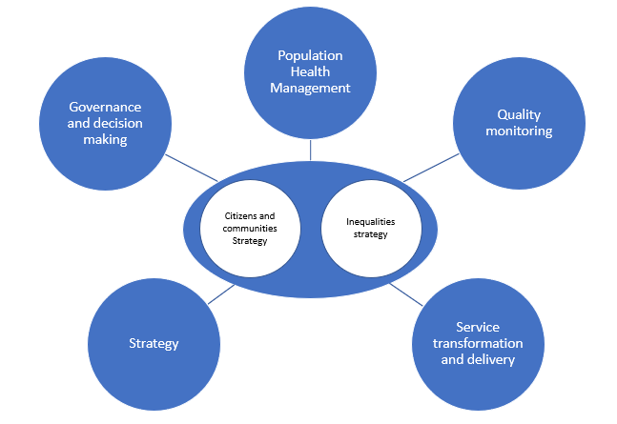
Work to develop the ICB priorities is ongoing, however, building on the current work of the shadow ICB there are key roles for involvement in the following priority areas:
- Supporting the delivery of the Inequalities Strategy
- Embedding a Population Health Management Approach driven by community involvement
- Development of the Coventry and Warwickshire Strategy by the ICP
- Transformation, restoration and redesign of services
- Ongoing response to the pandemic and vaccination programmes
- Maintaining inclusive, high quality services
The ICB will inherit a strong engagement and involvement ethos from the Clinical Commissioning Group which precedes it, and we will build on that knowledge and the structures already in place, as well as that of all the organisations across the ICS.
These priorities, and the actions that support them, will evolve and develop through the life of the strategy. We will further develop our strategy for delivering against these objectives as we develop as an ICB, and individual involvement plans will be developed to address each priority, building on the work which has been undertaken across the ICS.
Although these are the priorities of the ICB and ICP, it should be noted that much of the involvement is likely to take place within and driven by the Care Collaboratives and not solely through the ICB structures.

Population Health Management

Priority – Embedding Population Health Management
The role of involvement  Moving to a Population Health Management approach is a key priority of the ICB. As the ICB develops this approach, involvement and the gathering of qualitative data to inform decision making will be an integral part of reducing health inequalities and enabling us to identify and address physical, mental and social wellbeing priorities of the population and reduce the variance in support which has previously contributed to inequality.  Population Health Management puts the individuals and communities at the heart of their own care, wrapping services around them and supporting them to take control of their own care. Involvement will be key in delivering this, building relationships with both communities and with the third sector who will be integral to the work. | Involvement in Action – Healthier Communities Together in Coventry  As we transition to an ICS, working collaboratively across the system will be vital if we are truly improve healthcare outcomes and address the wider determinants of health. However, in order to facilitate more effective partnership working, the infrastructure that allows for collaboration must be redesigned to reflect the closer cross-sector relationships that will be established when the ICS is formed.  The Healthy Communities Together programme has created a cross-sector strategic team to create a more collaborative approach to tackling health inequalities consisting of Coventry City Council, Coventry & Warwickshire Partnership Trust, Grapevine and local GPs. By using a hyper local model of collaboration, the aim is to put people with lived experience of mental health needs, community groups, and small voluntary and community sector organisations at the heart of decision making.  This new way of working will empower communities to determine the shape of their healthcare services and create new relationships between people, service providers, and the voluntary and community sector.

Delivering on the priority
We will continue to build upon this approach through the work to develop a shared insight database to support decision making for Population Health and building trust with communities to build understanding of their priorities (Pg. 19). Our work with developing relationship with the third sector, building on initiatives already in place will be integral to delivery.

Reducing health inequalities

Priority – Supporting the delivery of the inequality strategy
The role of involvement  Through involvement and understanding of individual communities’ priorities and aspirations, we will be able to design and deliver services tailored to meeting those priorities, improving access and ultimately reducing inequalities for the local population.  This work will encompass all the partner organisations within the ICS building on best practice to understand priorities | Involvement in Action – Building community links through local champions  We know that the South Asian Community are at an increased risk of diabetes compared to the white population. Diabetes brings with it the risk of long-term complications such as heart and kidney disease, amputations, and blindness. It is therefore key for us to address these inequalities if we are to achieve equitable health outcomes.  The Diabetes Community Champions programme was established to raise awareness of the condition within high-risk communities. These Champions are volunteers from within the communities we are aiming to reach, which means they can effectively engage with their community in a culturally competent way. They form a vital link between the NHS and their local community, and they carry out crucial work to educate and raise awareness of diabetes.  There are now 30 Diabetes Community Champions operating in Coventry and Warwickshire and the programme has proved extremely effective at engaging with high-risk communities. The community champions have supported with delivery of culturally competent outreach events, including cookery classes with a focus on authentic South Asian recipes to support healthy living in a sustainable way and delivering other health information.

Delivering on the priority

This work is closely tied to that of the Inequalities Strategy and a separate delivery plan will be developed to support this work.

In Appendix 3 you can find examples of how well delivered, culturally competent involvement will support a reduction in health inequalities and reduce the prevalence of risk factors in our communities - two key priorities of our ICB. Using a logic model, they also show the assumptions which we have made and examples of how we intended to measure our success.

Strategic development

Priority – Development of the ICP strategy for Coventry and Warwickshire
The role of involvement  The Integrated Care Partnership (ICP), along with the two Health and Wellbeing Boards for Coventry and Warwickshire, will be responsible for setting the strategic direction of travel for Coventry and Warwickshire, with a focus on how we can reduce health inequality and improve outcomes.  Supporting meaningful involvement of communities for the ICP will be essential in ensuring that this strategy identifies and responds to the priorities of all residents of Coventry and Warwickshire. | Involvement in action - Compassionate Communities (Community Connections) in Coventry and Rugby  The Compassionate Communities movement seek to improve the mental wellbeing of young people through Narrative Inquiry models. Our research has shown that those involved report an improvement in wellbeing and increased social inclusion and attribute this to ‘being given a voice’.  Based on the above experiences and evidence different forms of ‘narrative/story circles’ have been facilitated with approximately 400 young people since July 2021; these story circles have largely been based around the experiences of young people through the pandemic. Groups of 6-8 people come together and are invited to share their story uninterrupted, others then, respectful of what has been offered engage with this story. The participants decide the themes that are important to them. They in effect create a new and previously unspoken narrative that belongs uniquely to them. The group themselves then decide what this means to them and their life experience and the ‘so what’ moving forward.  The majority have been secondary school age but significant numbers of students in further and higher education have also participated. Participants have come from schools and colleges, uniformed organisations, the Positive Youth Foundation, faith groups and individuals that have responded to social media.  The themes that were recognised within the story circles included bereavement and loss, depression, isolation and loneliness, suicide, negative and positive impact on education, positive and negative impact on family life, impact on eating disorders, sexuality, relationships/friendships, loss of hope for the future etc. Depending on the context of the group different forms of wellbeing measurement are used. These range from simple ‘emojis’, to in other groups the Warwick and Edinburgh Mental Wellbeing Scale (WEMWBS) is used to measure perceived wellbeing at the start and after the group.

Delivering on the priority
Building on the community links already in place and the work of the Health and Wellbeing Boards, a full involvement plan will be developed to ensure that this work is developed with the input and support of local communities.

Service transformation and delivery

Priority – Restoring services
The role of involvement  To develop culturally competent services which people want to use and create new pathways for care which reduce inequality, we need to understand how they will be received by the varied and diverse communities across our area.  This entails establishing more meaningful relationships and seeking joint solutions in partnership with communities, putting communities at the heart of our planning and decision making around the services which they use. Supporting the development of individuals and community representatives to help shape our services, using health and care experience profiles to inform planning and using co-production approaches will all lead to better services and improved access, reducing health inequalities.  Restoring services inclusively will require involvement of the local population to ensure that those services continue to meet the needs of individuals and we rebuild local service provision to meet the physical, mental and social needs of communities affected by severe economic and social disruption throughout the pandemic. | Involvement in Action - Shaping services with people who are homeless or vulnerably housed  The Anchor Centre in Coventry is a specialist GP service, designed to meet the needs of the local homeless and vulnerably housed population. When it needed to be reprocured it was imperative that this was done in partnership with those who used the service so we could be assured that the service was fit for its users and delivered by a provider who understood the specific challenges faced by this cohort.  The involvement team from the Clinical Commissioning Group undertook an extensive piece of engagement with the local homeless population, attending drop-in centres and other support services to talk directly to people and understand their experiences, what mattered most to them about the healthcare services they receive and how they thought they could be improved. Third sector organisations were also engaged with to learn from their experiences of working with people who are homeless and what worked best. This learning was all fed into the development of the service contract, adding addition outreach requirements which were deemed a necessity for support.  This work was also used to craft questions for potential providers which would test their understanding of the needs of this cohort. Third sector representatives who worked with people who are homeless and Healthwatch Warwickshire sat on the evaluation panel, considering the responses and ensuring that the successful provider would be able to deliver a GP service which worked for this group. This approach allowed the voice of this often marginalised cohort to be represented and listened to throughout the process, ensuring the service addressed what they told us mattered most and has been taken forward as a model for local involvement in the redesign of NHS services for the CCG.

Delivering on the priority
As restoration of services continues, the work outlined against Objective 1 (Pg. 15) will create the structures to support ongoing involvement of communities to inform this work and put individuals and communities at the heart of our restoration work.

Service transformation and delivery

Priority - Supporting delivery of ongoing vaccination campaigns
The role of involvement  Good involvement has been instrumental in ensuring uptake of vaccination across the diverse communities of Coventry and Warwickshire.  Working together across ICS organisations we were able to reach into communities we had not previously had strong links to and work with then to understand their priorities and the barriers to vaccination. We developed new groups and links and were able to support local communities to deliver their own messages in their own way | Involvement in Action – Supporting Vaccination amongst Children and Young People  Widespread vaccine uptake across all age groups was vital to our response to Covid, both to reduce the risk of serious illness and to reduce transmission within the community. However, certain sections of the younger demographics were showing hesitancy in getting vaccinated.  The Positive Youth Foundation organised a live vaccination Q&A session where over 50 young people met with staff from the CCG and Public Health in Coventry. The panel were asked a range of questions and addressed concerns or misinformation that were causing vaccine hesitancy amongst the attendees.  Whilst only a relatively small group, this type of engagement work is crucial to give the public, particularly those who have doubts over getting vaccinated, a chance to ask direct questions to NHS professionals. The Positive Youth Foundation saw an increase in confidence in vaccines amongst young people following this session. To further increase vaccination uptake, some of the group decided to make a video to spread the word about the importance of vaccination to their peers, leading to a much wider reach.

Delivering on the priority

Building on the good links already in place across the ICS, involvement will continue to drive uptake for the vaccination campaigns across 2022/23

Quality Monitoring

Priority - Maintaining inclusive, high quality services
The role of involvement  It is not enough to design evidence-based services, we must ensure that the services remain suitable for the diverse communities that they serve. To do this, experience must be gathered through involvement with local communities and be heard and acted upon, with learning recorded and embedded.  This means creating a culture of always listening and learning, and of sharing our knowledge between organisations so we can identify potential issues quickly at a system level, whilst also feeding information to where it can most make a difference - at Place and Neighbourhood level. | Involvement in Action – Using Patient Feedback to inform campaigns  Following patient and carer feedback to the Quality team on the lack of education and information on decisions some patients may need to make when unwell, the CCG worked closely with the Quality team, local advocates, charities, Healthwatch and those with lived experience to design a new communications campaign to raise these issues.  Having discussions with loved ones about your wishes, should you be suddenly taken ill, injured or at the end of life, are not easy conversations to have. Whether you are having this discussion due to a terminal diagnosis or just because you want your loved ones to be better prepared. The campaign was co-designed to support people to be prepared – how to talk about it, plan for it, and record your wishes with useful resources.  This work led to a Coventry and Warwickshire wide bus campaign to empower people to discuss their life choices with supported online information and materials. The bus campaign covers the geographical areas below on 30 bus rears over the summer of 2021, once pandemic restrictions were lifted. Digital content (website and social media) and staff messaging have been created and shared with CCG staff and all health and social care across the system to promote the campaign.  All campaign materials have been created in partnership with the complaints team, patients, clinical leads and Compassion in Dying (national charity). The online resources and packs available offer a range of advice and guidance to support discussions and help people plan, all information is hosted and directed to the CCG website.  In addition to the above campaign, all printed resources and materials have also been posted to primary care practices, care homes, hospices and secondary care quality and safeguarding leads across the provider trusts to further increase the reach.

Delivering on the priority

This work will be supported through development of an Involvement Network and inclusion of our quality functions from across the ICS that is outlined on Pg. 18. This work will further be supported by the development of a shared insight function, outlined on Pg. 19

Individuals and communities in ICB governance and workstreams

How is the ICB listening to people and communities
As the statutory organisation leading the integration of NHS services, local authorities and local partners, it is critical that the ICB is able to demonstrate that it is meeting its legal duties and provide assurance that effective involvement is taking place across the system from the day it becomes a statutory organisation.

Our routes for engagement have been mapped to the 10 Principles of Engagement to demonstrate the current mechanisms in place and identify areas to be improved through the life of the strategy.

 | - Put the voices of our people and communities at the centre of decision-making and governance
The voice of Coventry and Warwickshire individuals and communities must be built into the governance arrangements of all our key decision-making forums within the ICB and ICP to demonstrate that we are listening to and acting upon what local communities are telling us.

The Board of NHS Coventry and Warwickshire Integrated Care Board  - The ICB will appoint five independent non-executive members to the board to bring independent and respectful challenge to its plans and promote open and transparent decision-making  - To ensure there is transparency around decision making, all meetings of the ICB will be held in public and will be widely advertised to encourage members of the public to attend. The minutes of the ICB meeting will also be published to allow those who are unable to attend the opportunity to review discussions and decisions that are made  - The board membership will include partner members from both Local Authorities which will help to create connections to local communities via local democratic representatives  - The ICB constitution includes information on how it involves people and communities, and the principles it follows in implementing these arrangements |  | Coventry and Warwickshire Integrated Care Partnership  - The Partnership will have responsibility for developing the Integrated Care Strategy for the population of Coventry and Warwickshire, covering health and social care and addressing some of the wider determinants of health and wellbeing. The citizen voice will continue to be represented at this board as through the ICB  - The expertise of professional, clinical, political and community leaders will play a key role in the partnership membership, as well as Healthwatch as the statutory body for understanding people’s views  - Meetings will take place in public to support transparency and local accountability, and minutes of these meetings will also be published online and made available to the public  - Best practice involvement and engagement of individuals and communities will be employed in the development and monitoring of the strategy to ensure that it is reflective of the priorities of local communities, building on the two Health and Wellbeing strategies for Coventry and Warwickshire.
As further structures are developed to support the ICB, it will be responsible for ensuring that they also apply the 10 principles appropriately. This includes our wider committees which support the activities of the Board and our Care Collaboratives in Coventry and Warwickshire which bring together NHS, local authorities and other system partners within each county to collectively plan and deliver services. The voices of individuals and communities will be achieved through:

- Including representation from people and communities
- Building on existing engagement approaches at place, including health and wellbeing boards and primary care networks, as well as support the development of the ICS framework/principles
- Working closely with the VCSE sector and Healthwatch (See Principle 5)

Actions for development in 2022/23
- Work with the third sector to increase participation in our decision-making forums  - Further development of our committee structure to ensure appropriate representation at all levels |  | - Training and development for our non-executive directors and other representative participants in decision making forums to ensure they have the tools that they need to contribute effectively and hold the ICB to account if the voice of the individual has not been considered

 | - Start engagement early when developing plans
Involvement and engagement must form an integral part of all stages of our work, ensuring that individual and community input is sought and informs all aspects of developing and delivering our plans, from initial scoping and planning, to delivery, to monitoring and evaluation.

Initial scoping and planning
Embedding engagement into our scoping and planning will be achieved through adoption of our Population Health Management approach, where qualitative data, gathered through involvement, will inform part of our initial scoping and understanding of community priorities and our planning will be based on what local communities have told us they need.

Ensuring best practice engagement and consultation
Once a priority has been identified, we will adhere to the measures outlined in the “Good Engagement Charter” developed by our local Healthwatch organisations in Coventry and Warwickshire, which can be found in Appendix 4 – The Good Engagement Charter.

When undertaking formal consultation with the public, the ICB will adhere to the Gunning Principles.
- Consultation must be at a time when proposals are still at a formative stage;
- The proposer must give sufficient reasons for any proposal to permit of intelligent consideration and response;
- Adequate time must be given for consideration and response; and
- The product of consultation must be conscientiously taken into account in finalising any statutory proposals.

These principles are reflected in the Good Engagement Charter and will also be applied to our engagement work, regardless of whether it will entail formal consultation or not, to ensure that involvement is always considered appropriately as part of all our activities and is started early in the process when plans are at a formative stage.

Equality and Quality Impact Assessments
All plans which are considered by the ICB must have an Equality and Quality Impact Asessment (EQIA) which outlines both the impact of any changes on the local population, particularly those with a protected characteristic, and what mitigations can be put in place to address any negative outcomes. These assessments must be informed by involvement of individuals and communities who may be affected by the changes and represent another route for the voice of individuals and communities to be involved in our planning.

As the ICB develops we will explore how we ensure our EQIAs remain integral to our development of services. This will include
- How we approach them in our governance to ensure EQIAs are completed in a comprehensive manner as the plans are being developed
- Train our staff to understand both the mechanics of developing a best practice EQIA and the importance of why it is necessary.

In addition to EQIAs, Healthwatch locally are able to develop Patient Public Impact Assessments to ensure all needs of local populations are considered in planning

There is a wider piece of work taking place to develop a “gateway approach” to the projects and programmes of the ICB. This will provide consistency across the organisation and ensure that all work adheres to a standard set of principles. EQIAs and Patient Public Impact assessments are likely to form part of this approach to embed involvement, individuals and communities at the heart of everything we do.

Actions for development in 2022/23  - Supporting the development of the good engagement charter |  |  | - Further work to embed EQIAs within our governance
 | - Understand our community’s needs, experience, ideas and aspirations for health and care
Understanding the diverse communities within Coventry and Warwickshire and delivering joined up services based on their needs and priorities is at the heart of our Population Health Management strategy. Involvement plays a key role in this approach, supplying the qualitative data on community priorities, experience, ideas and aspirations to accompany the quantitative information and giving us a clear route to embed it into our planning.

Gaining the trust of local communities will be a key part of this work and we must ensure that once we do understand the priorities of communities we act on them.

This insight will be gathered in several ways:

- Across the ICS partner organisations, particularly in the local authorities, there are strong links with many communities. Through developing our system approach to involvement and pooling our engagement and insight knowledge between ICS partner organisations, both the ICB and ICP will be able to access a much wider breadth of insight to inform decision making.
- The Communications and Engagement function within the ICB retains a strong outreach function, with community champions across the area and positive links to local community groups and organisations. Through a combination of targeted engagement on priority areas, and an ongoing calendar of community health and wellbeing events, we can build connections with our organisations and feed that information back into our service development and quality functions.
- Our Healthwatch organisations gather wide reaching insight into community priorities through their ongoing work programmes, which will be shared with the ICB to inform our planning and service development.
- Voluntary, community and social enterprise organisations across Coventry and Warwickshire have a deep understanding of local community priorities. As the Voluntary, Community and Social Enterprise Alliance develops, we will be able to equip them with the tools and resources they need to share that insight and be involved in our planning and decision making on behalf of the communities they serve.
- As Care Collaboratives, Places and PCNs develop, they will undertake their own local insight and engagement activities at Place and Neighbourhood level. We will explore how this can be linked into the wider information resource.
- We have many existing mechanisms in place in NHS organisations to hear from individuals and communities. This includes Patient Participation Groups, Patient Advisory Liaison services (PALs), experts by experience and community champions.
- In Coventry, through the One Coventry initiative there has been a collective commitment to community and resident collaboration agreed, which will take forward developing an engagement approach with Coventry residents

Link – Population Health Management Strategy

Actions for development in 2022/23  - Exploration of a shared repository of engagement information |  |  |  | - Ongoing work of our Care Collaboratives to develop new mechanisms for engagement

 | - Build relationships with excluded groups, especially those affected by inequalities
As referenced in Objective one, building trust with local communities, particularly those who are within excluded groups, will be key to the success of the ICB. This work links directly with that of the Inequalities strategy and the development of our Core 20 plus 5 groups for Coventry and Warwickshire. Key to building trust is reaching out, listening and showing understanding and then demonstrating that something is done based on what people say, or we are clear and transparent when it can’t be done.

Through developing our cultural competence, we will better build our relationships with excluded groups and understand and address their priorities.

The actions which fall under “Build trust and relationships through always listening and learning” (Page 19) will be instrumental in developing these relationships.

We are not starting from scratch and the work undertaken by the individual organisations which make up the ICS and our Care Collaboratives will be key. Our first step will be to map engagement and involvement activity and assets across the system to reduce duplication and identify gaps, cross referenced against the Core 20 plus 5 cohorts so we ensure that we can prioritise those groups most marginalized appropriately.

Actions for development in 2022/23  - Supporting the delivery plan against Objective one |  |  | - Ongoing work delivered by the Care Collaboratives to build relationships

 | - Work with Healthwatch and the voluntary, community and social enterprise (VCSE) sector as key partners
Healthwatch

Local Healthwatch organisations are the health and social care champions with functions set out in legislation. They exist to give people the opportunity to share their experiences of health and social care services and make sure that this valuable feedback reaches those who run, plan and commission services. Healthwatch looks at things from the point of view of local people and communities and has a role in accountability and scrutiny.

The two local Healthwatch organisations have published a Memorandum of Understanding regarding closer working and the ICS is supportive of this work. We are fortunate to already benefit from strong positive relationships with both Healthwatch organisations and will seek to build on this to agree a system-wide approach to working effectively with them.

Healthwatch will be represented on both our ICB and ICP and help us to ensure that the voice of our communities and individuals is at the heart of everything that we do.

Voluntary, Community and Social Enterprise (VCSE) sector
Across Coventry and Warwickshire, we have a large and vibrant VCSE sector, ranging from small “grassroots” groups entirely staffed by volunteers to large organisations with a remit which spans the whole ICS area and beyond.

There are several structures which bring VCSE organisations together across geographical Places. This includes “Thriving Communities” in Warwickshire, which brings together VCSE and public sector organisations to drive change, build relationships and create opportunities for all aspects of the VCSE in the area. In Coventry, the VCSE organisations have formed a “VCSE leaders’ group”, a collective of leaders of medium to large voluntary, community and social enterprise providers who are committed to working together to bring about positive change for the whole city.

We have two organisations who work with our communities on a geographical place basis. Warwickshire Community and Voluntary Action (WCAVA) supports volunteers, groups, organisations, enterprises and charities across Warwickshire and Voluntary Action Coventry (VAC) promotes and supports social action and community resilience in Coventry, strengthening communities, building capability and improving quality of life for residents in the city.

Warwickshire County also invests in the Warwickshire Pan Equalities Service for which the contract is currently held by EQuIP. The Service works towards the elimination of unlawful discrimination, to promote equality of opportunity and good relations between people of different groups under each of the protected characteristics as set out in the Equality Act 2010 within and across the public and third sectors.

VCSE organisations with a focus on mental health have worked together to form the “Mental Health Alliance”, aimed at bringing together representatives with a mental health focus in one collaborative community and allow the whole of the VCSE mental health sector to be included in mental health transformation.

These diverse structures are all working individually to address the needs of our population across Coventry and Warwickshire but there is no single organisation or voice which could currently act as a representative for the VCSE across Coventry and Warwickshire. VCSE representatives working with the ICS had already identified the need for a group or alliance which brings together representatives from across both geographical places and is able to be a collaborative, representative voice for the voluntary sector at an ICS level.

Initial work has started on how we address this, bringing together a group of VCSE leaders with representatives from the NHS and local authorities to explore how we can facilitate representation of the VCSE within the ICS, who should be involved and how we can ensure that any group is truly representative of the VCSE across both Coventry and Warwickshire, and of the diverse communities which we serve. Additional work to support the involvement of the “grass roots” community sector is also in train, understanding what networks are already in place and what they need to be in place to support them to be involved on their terms.

Actions for development in 2022/23  - Ongoing development of mechanics to allow representation of the sector across the ICS  - Mapping of the current networks of within the sector across Coventry and Warwickshire |  | - Work with the grassroots organisations to understand priorities and promote involvement

 | - Provide clear and accessible information about vision, plans and progress to build understanding and trust.
Ensuring all individuals and communities in Coventry and Warwickshire can access information about the work of the ICS, ICB and ICP, being clear where people can get involved, the decisions we are making and how they can be involved.

As an organisation we are open and accountable to the population we serve and ensuring all individuals and communities in Coventry and Warwickshire can access information about the work of the ICS, ICB and ICP is vital in supporting involvement. We publish our “Functions and Decisions Map” so that anyone who wishes to be involved can understand where all the decisions that we make are made, in addition to clear information about our ICS and its structures.

Our website has been developed in line with all the latest accessibility guidance and in line with our principles for clear, accessible language. It contains all board meetings and papers in an easily searchable document library. It also offers lots of ways to get in touch, including how to attend board meetings, where we welcome questions from the public, places to submit complaints, comments or Freedom of Information requests, and an up-to-date list of all the current engagement and consultation being undertaken by the Board and opportunities to get involved. It also includes the details of the two Healthwatch organisations and how to speak to them if people need to.

When developing information on our vision, plans and progress we strive to communicate in a way which is clear, simple, impactful, and self-evidently useful – using normal language, not jargon.

Our ICB will continue to produce an annual report through which we will demonstrate public involvement in our activities. In addition to our statutory annual report, we also aim to produce an Engagement Annual Report, offering a more in-depth look at our involvement activities and how we are fulfilling our statutory obligations to the public.

COVID-19 has meant the way that people consume information has changed, although not always for the better. Digital has become the default for organisations broadcasting information, but we are mindful that there is a potential to exclude those who are unable to access online information. As a new organisation we will reassess our current communications tools in light of the changes in how people access information due to COVID-19. The channels which we will assess include:

- Website and intranet  - Printed documentation  - Design & digital  - Social media  - The media  - Questionnaires and surveys | - Marketing and campaigns  - E-newsletters/newsletters  - Face to face engagement  - Outreach and health intervention work

Actions for development in 2022/23  - Reviewing and strengthening implementation of the NHS Information Standard across the ICS  - Adoption of Plain English standards across the ICS, including guidance for writing for the public for web and other formats |  | - Ongoing assessment of our communications channels across the ICS to reduce digital exclusion and ensure they are fit for purpose

- Use community development approaches that empower people and communities, making connections to social action.
It is important that we support and build on our existing community assets, rather than attempting to overlay new structures. Across Coventry and Warwickshire there is a wealth of assets which already bring people together whether faith groups or those based around a specific culture or communities, our two universities, many diverse schools and community venues. Local voluntary and community organisations also play a vital role in supporting individuals and communities across the area, often reaching people that statutory organisations will never be able to engage.

There are already groups in place to support health and care, for example Patient Participation Groups have already established links around GP practices reaching out to their local communities, and we would build on the development of these groups in an inclusive way to reach out to communities.

The core of community development is building trust and meaningful relationships with local communities. This is an area where our local authorities have taken the lead and the structures and connections they have developed will be the bedrock of engagement for the ICB, driven by the two Care Collaboratives for Coventry and Warwickshire.

In Coventry, the Community Resilience Team (CRT) has set up a range of new community organisations and charities with a focus on supporting people. The support given is from idea stage right through to running the first project and includes help with setting up a charity or group, opening bank account, obtaining first small pot of funding and planning how to deliver their passion. CRT also supports the many (around 300) groups and organisations a year who, once set up, need help continuing to run which can include help with recruiting trustee and volunteers, help running a premises, fundraising or becoming a trading charity as just a few examples.

Recent examples of new groups set up include; Park Warriors, a fortnightly citywide support group set up by women with Parkinson’s Disease to provide exercise and friendship., Confidence Through Photography, a support group for people with mental health and anxiety issues, and Chit Chat Group Canley, we supported the setup of a new group for residents to meet new people and reduce feelings of loneliness.

Community centres in Coventry are valuable as they host the majority of the small community support groups such as lunch clubs, friendship and self-help groups. To ensure the centres stay open, the City Council have created the Community Centre Consortium where they work together collectively – including joint funding bids and commissions and hopefully in the future procure together to gain economies of scale. This consortium is well linked in with the groups its hosts so provides another engagement mechanism.

In Warwickshire, the County Council has a long-established community development function, taking an asset-based approach in priority areas, and employing 9 dedicated workers, backed up by specialist roles including Time Bank Co-ordinators. Some of the borough and district councils also have dedicated community development resources, most notably North Warwickshire Borough and Warwick District.

Various County Council initiatives including “Start with Strengths” and “Child Friendly Warwickshire”, and work to embed principles of restorative practice across much of Social Care, also reflect asset-based approaches, empowering people and communities and encouraging social action.

At the heart of the Community Powered Warwickshire programme is the principle that communities have the skills, knowledge, and assets to identify and put forward solutions to their own priorities. Community Power is a cross-cutting theme in the new Council Plan.

The new VCSE Sector Support Service from 1 April 2022 include a section devoted specifically to building social action in priority communities.

Actions for development in 2022/23

- Build upon the work already in place to support and develop our community development pathways

- Use co-production, insight, and engagement to achieve accountable health and care services

We must choose the best approach to engagement depending on the specific circumstances, ensuring it is fair and proportionate, and takes place at a time and in a way that means it has a genuine role in decision-making.

We are clear that one-size fits all is not an option when it comes to involving the diverse communities that make up Coventry and Warwickshire and we must tailor our approach appropriately, rather than assuming we know best, and listen to what people tell us their priorities are. How we will come together as a system to develop our ways of engaging forms a key part of our first objective detailed on page 15

The JSNA forms a vital part of the insight which will be used to make a difference. For example, in Warwickshire the completion of place based JSNA assessments (22 local assessments) in 2019, which involved community engagement to help identify local priorities and solutions, are used to target resources at appropriate health and care services. A further round of thematic JSNA assessments will help build to build the insight and evidence base.

Making services accountable also means feeding back the change’s involvement makes to communities and continuing a cycle of feedback and involvement. More information on this can be found on pg. 21

Actions for development in 2022/23

- Progress the work outlined in Objective 1 (Pg. 15) building on the mechanisms already in place

- Co-produce and redesign services and tackle system priorities in partnership with people and communities

We know that people who use health and care services have knowledge and experience that can be used to help make services better. Co-production is a relationship where professionals and citizens share power to plan and deliver support together, recognising that both have vital contributions to make to improve quality of life for people and communities.

Across the ICS we have many groups which we already interact with who feed into our services and support us to make the services better. Most of these work directly with individual organisations and form part of the engagement process from PPGs to community-based organisations. As outlined above, the Local Authorities in the ICS have championed the use of co-production for our system and much of the engagement will be taken forwards though the two Care Collaboratives, linking closely to our ICB.

In Coventry there are community stakeholder meetings in keys areas of the city such as Willenhall, Foleshill and Hillfields. These are in the main run by the community resilience team and where possible (and there is a community appetite) run by community organisations. These meetings help the various groups and organisations in the voluntary sector of that community work better together as a collective as well as working with statutory partners to communicate and deliver their priorities.

The Healthy Communities Together project (pg. 23) in Coventry is an example of how services are being co-designed with residents to meet system priorities.

In Warwickshire, the County Council has established a Co-production collaboration and discussion group and has an aspiration to establish a co-production framework. Parts of the Council now routinely co-produce services.

The coproduction and redesign of services in partnership with people and communities is a core feature of the County Council’s Community Powered Warwickshire programme. The Social Value Policy approved in September 2021 is likely to drive forward more co-productive approaches.

Developing how we deliver co-production as an ICB in Coventry and Warwickshire will form part of the work of the involvement network (Pg. 18), building on the work of the Local Authorities and health providers in this space.

To move to a system where we work with individuals and communities as partners in the production and design of services is a long-term objective which, as detailed on pg. 17 involves a cultural shift across the organisations of the ICS to put people at the heart of everything we do.

Actions for development in 2022/23

- Progress the work outlined in Objective one (Pg. 15) building on the mechanisms already in place

- Learn from what works and build on the assets of all health and care partners

As has been referenced throughout this document, there is excellent practice taking place within all member organisations of the ICS and we are not starting from scratch in developing how we do things.

The development of an Involvement Network (pg. 18) will support collaboration between all system partners, building on our collective skills, knowledge, and networks.

An exercise to identify all the activities currently happening across partner organisations will support us to understand best practice, identify any duplication and gaps, and share best practice through our Involvement Network. Through understanding what is already in place we can start to build a culture and mechanism for sharing and planning together as an ICS, removing silos and fragmented approaches and working across organisational boundaries when this is the best thing to do.

Actions for development in 2022/23

- Ongoing development of an Involvement Network for sharing best practice

Roles, responsibilities and resources

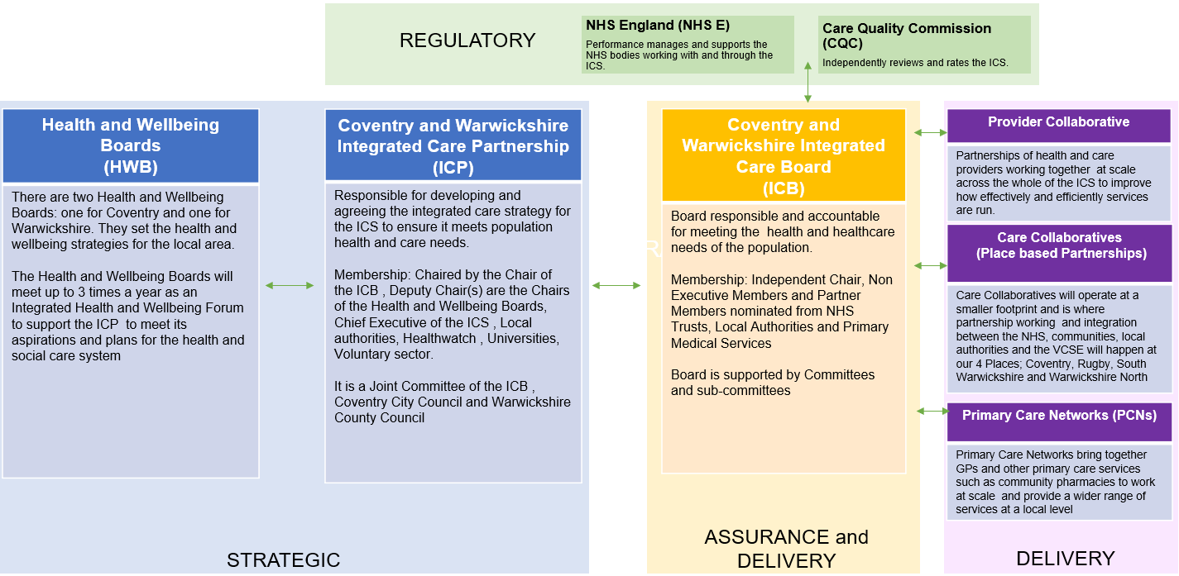
The above Functions and Decision Map outlines the various structures and organisations which make up Coventry and Warwickshire ICS.

Roles and responsibilities
The ICB holds the responsibility for the delivery of this strategy, ensuring people and communities are involved in the planning of services, proposals and decisions having an impact on services, using the methodology outlined in this document. It is also responsible for demonstrating that the legal duties are being met at all levels outlined in the Function and Decision Map and will do so using the framework approach outlined on pg. 17.
Full details of how the ICB and ICP will deliver on their responsibilities to put people at the heart of everything they do can be found on pg. 30.
Within the members of the Integrated Care Board, there will is an SRO for Engagement and Involvement who will be responsible for championing the strategy at the ICB and with the senior leaders within the ICS to support the cultural shift outlined in Objective 1.
Within the membership of the Board there will also be an ED&I champion, a Wellbeing champion, and PPI champion, drawn from the Non-Executive or Partner members. These roles will also retain responsibility for ensuring that the requirements around involvement are met.
The work of the ICB will be supported through the Communications and Engagement Team currently with the Clinical Commissioning Group.
Although the ICB holds the responsibility for the strategy, through the Involvement Network, all partner organisations of the ICS will take responsibility for wider implementation of the strategy, agreeing and operating within the framework approach.
As the Care Collaboratives and Provider Alliance continue to develop, they will hold responsibility for ensuring that their work is developed with individuals and communities, in line with their legal duties and as part of the agreed framework for Coventry and Warwickshire.
The Integrated Care Board  Delivery of this strategy, ensuring people and communities are involved in the planning of services, proposals and decisions having an impact on services, using the methodology outlined in this document.  Demonstrate legal duties are being met at different levels  Develop health and care plans with and for individuals and communities | Integrated Care Partnership  Development of the Coventry and Warwickshire Integrated Care Strategy with individuals and communities  Include wider public representation in their membership  Ensure strong connections to communities and democratic representatives | Care Collaboratives  Engage with individuals and communities on their plans and decisions  Build on existing ways of working to involve people in decision making  Support PCNs and neighbourhoods to engage and involve their local communities | Provider collaborative  Build on existing ways of working from across the partner organisations in involving local communities  Ensure their work is informed through insight and feedback  Use the Coventry and Warwickshire framework as it is developed to involve and meet legal duties when planning and delivering change

Resources
The work of the ICB will be supported through the Communications and Engagement Team currently with the Clinical Commissioning Group. The strategy will be delivered through the involvement teams from the partner organisations of the Integrated Care System and the Involvement Network as it develops.

Monitoring and evaluating the strategy

Approach to reviewing engagement activity & impact
This strategy outlines a change of approach and a cultural shift in how we do things, building trust with our communities and putting people at the heart of everything we do. The first year of this strategy will be focused on working with individuals and communities to create the conditions in which that can take place and there are agreed deliverables through which we will monitor the initial success
- Development of a framework / set of principles, informed by engagement with our local communities, that all partner organisations within the ICS have agreed to operate within
- Establishment of an involvement network
Following the successful development of these two areas, we will use them to monitor the other areas identified in as key actions to achieve our vision
- Promote cultural change across the ICS to put people at the heart of everything we do
- Build trust and relationships through always listening and learning
- Equip everyone with the tools they need
- Demonstrate the difference that community involvement makes
We will develop an evaluation methodology to support ongoing monitoring of our work based on the framework / set of principles mentioned above, the Healthwatch Good Engagement Charter and using a logic model-based methodology as shown in Appendix 3. This process will be used to not only monitor the effectiveness of this strategy in understanding outcomes for individuals and communities, as well as our workforce, but also applied as part of the ongoing evaluation of all involvement activities.

Plans for feeding back to individuals and communities
As referenced throughout the strategy, feedback is essential in building trust and this must be a principle that is enacted through all levels of activity. As part of the Healthwatch Good Engagement Charter, we are committed to ensuring that feedback throughout our work is delivered throughout all of our work, not only at the end.
As noted in Action 3 (pg. 19) establishing culturally competent routes for feedback is vital and will form part of our ongoing engagement work.

Appendices

Appendix 1 – Additional Case Studies to show Involvement in Action across the ICS

COVID Community Action in Warwickshire
In response to the restrictions of the first lockdown in March 2020, and the resulting urgent need to support vulnerable and isolated people, many communities formed local support groups, providing food and essential household items, transport, prescription deliveries, and mental health support including befriending services.
The resulting informal network of some 300 groups across Warwickshire provided a lifeline to many people, but also a means of community engagement for Local Authorities and Health. This widespread mobilisation is a lesson to public agencies in the ability of communities to recognise their own priorities and challenges, to act with pace in designing services, and to deliver services with high levels of efficiency. Outside of the pressure of a pandemic, this reinforces the value of coproducing services to ensure focus on the correct priorities, good design and efficient delivery.
There is also considerable innovation and examples of best practice at an organisational level where successful involvement and engagement has led to better outcomes and shown new ways of doing things which improve service access and reduce health inequalities.
Vaccine work with African and Caribbean Communities
From the start of the vaccination programme, it was clear that uptake levels were often vastly different between demographics. One of the groups identified as having low uptake was the diverse African Caribbean communities in the area and, through engaging with the communities, we learnt that one of the major concerns was not seeing the vaccine drawn out of the vial as pre-drawn syringes were used to maximise efficiency.
We decided to co-produce a video, along with members of the African Caribbean community, explaining the vaccine process which included showing what happens behind the scenes in a vaccination clinic. To ensure maximum effectiveness, we used healthcare professionals from the African Caribbean communities in the video.
The response was overwhelmingly positive, and the feedback indicated that members of the community felt reassured by being able to see the vaccination process and this resulted in an increase in trust in the vaccines.

Involvement in Service Change in South Warwickshire
South Warwickshire NHS Foundation Trust (SWFT) is currently undertaking a review of the inpatient beds at community hospitals within South Warwickshire; Ellen Badger Hospital and the Nicol Unit at Stratford Hospital. The focus of this review is to ensure that SWFT are providing the services that meet the health and care needs of the people of South Warwickshire, both now and in years to come.
The first stage of the review was exploring previous, current, and future use of the community hospital beds. Involvement and engagement of people who have used or may use Community Hospital services was central to guiding the review process. To support this SWFT commissioned Healthwatch Warwickshire to distribute and promote surveys to target groups, previous patients, potential patients and wider public and stakeholders. Healthwatch also independently analysed all survey results. Healthwatch are skilled at engaging with communities, groups, and individuals and reaching a broad range of stakeholders. To support accessibility, respondents were offered the opportunity to complete a paper based, online or telephone-based survey.
To gain further rich and in-depth insight into current patients experience of Community Hospitals, a series of face-to-face patient interviews were conducted across Ellen Badger Hospital and the Nicol Unit. Staff and wider professional stakeholders who either work at one of the current Community Hospital sites or professionals working closely with or referring to the Community Hospital provision were also asked for their views.
In November 2021 a technical panel, which included clinicians, therapists, operational and governance leads, staff side and HR representatives, as well as representatives from social care and Healthwatch Warwickshire, met to assess the viability of proposals taking into consideration patient safety, workforce delivery, local and national strategies and affordability. Only proposals that were felt to be viable were taken forward at this stage.
In December 2021, SWFT invited representatives from across the community to be involved in a community panel to further review and refine the proposals in line with what members of the community feel is important for us to think about as we progress the review. This panel had stakeholders from various voluntary organisations and community groups. Following the community panel, the technical panel re-met in January 2022 to consider the proposals in light of the feedback from community representatives and identify which of the proposed solutions should be investigated in more depth.
This review is still on-going and as it develops there will be further community involvement and engagement.

Community engagement the Coventry way
In summer 2020, Coventry City Council launched a community-led response to communications and messaging around Covid-19 that’s seen the development of more than 320 community messengers across the city. They share information in the way they know works for their communities and neighbourhoods and provide feedback and intelligence about how it really feels on the ground in these extraordinary times. The programme secured further funding from the Ministry of Housing, Communities and Local Government to build on this approach and recruit organisations and community organisations to assist as community champions.
Community messengers were recruited through existing faith, voluntary and community networks in the city. A series of webinars were held to provide initial advice and training and focus groups were held with young people to help develop specific messaging.
A weekly news update is emailed to messengers to share with their networks. The email update is long and detailed, and messengers pick and choose the items they would like to share. One messenger creates a weekly email for her neighbours and rewrites the information we provide into her style. Weekly webinars provide a forum for sharing and discussions for the messengers.
The network provides valuable feedback about what’s really going on in neighbourhoods. They tell us about the latest false news and disinformation that’s being shared on social media on things like vaccines. It helps us make sure we’re myth-busting when we need to.
When a walk-in test centre was set up in Foleshill, a ward with high levels of deprivation, it led to a backlash from the community as they thought we were stigmatising them. The decision to open a walk-in test centre was because of low levels of car ownership, but this hadn’t been explained. The feedback helped us address the problem and to explain fully.
Alongside the messengers’ network, voluntary and community groups are working with the Council to share communications. Webinars to brief community centres and places of worship are held when there’s a change in guidance and they are provided with regular phone advice and weekly update emails.
This work is just as important as our engagement with community messengers. Community centres and places of worship are supporting people through these difficult times by providing social supermarkets and other crisis support and they’re an excellent way to get ‘stay safe’ messages out as they are hubs in their communities.
The true measure of success is that this is more than engagement. Our community messengers and the community and voluntary groups are not simply passing on messages. They are actively complaining to big business where they see failures, recruiting people in the network to help and the voluntary and community groups are peer supporting each other as well as working collectively with us. We hope these benefits will continue long after the pandemic is over.

Appendix 2 – Delivery Timeline
This delivery timeline reflects the immediate key activities within this strategy and not the breadth of ongoing involvement across partner organisations
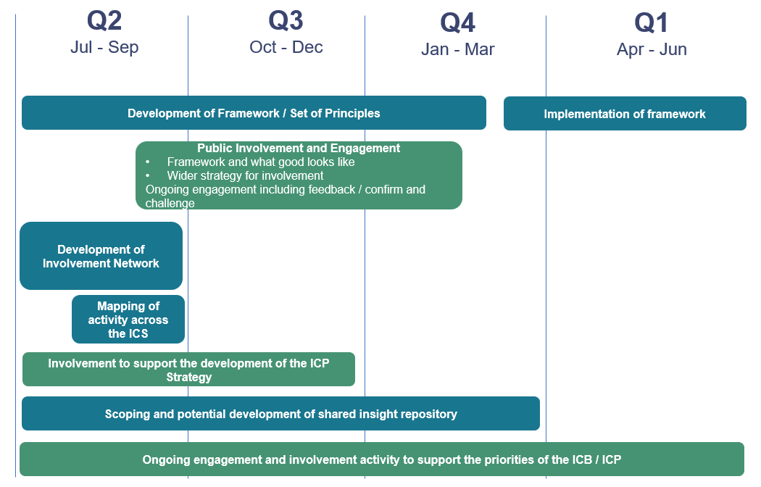

Appendix 3 – Involvement supporting health inequalities – example methodology
How involvement supports a reduction in health inequalities using a logic model methodology.

EXAMPLE: Use insight to deliver and evidence a reduction in health inequalities
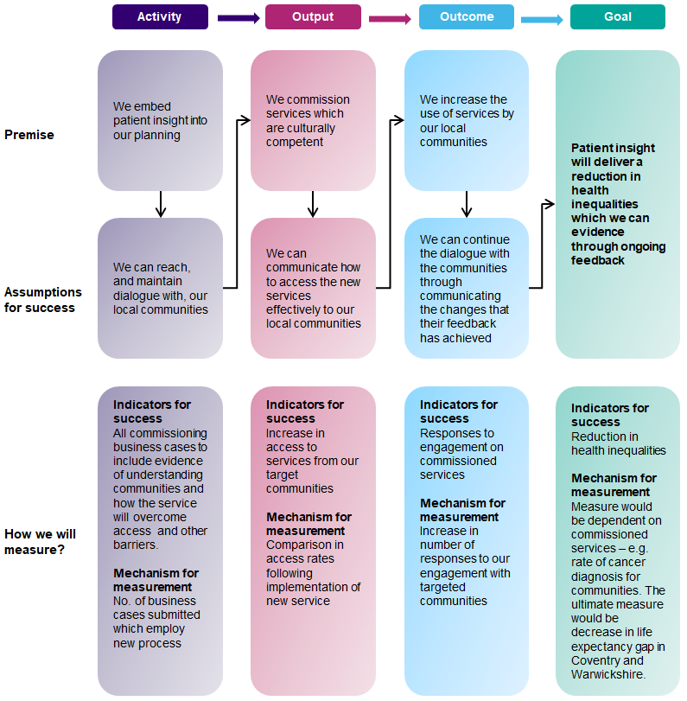

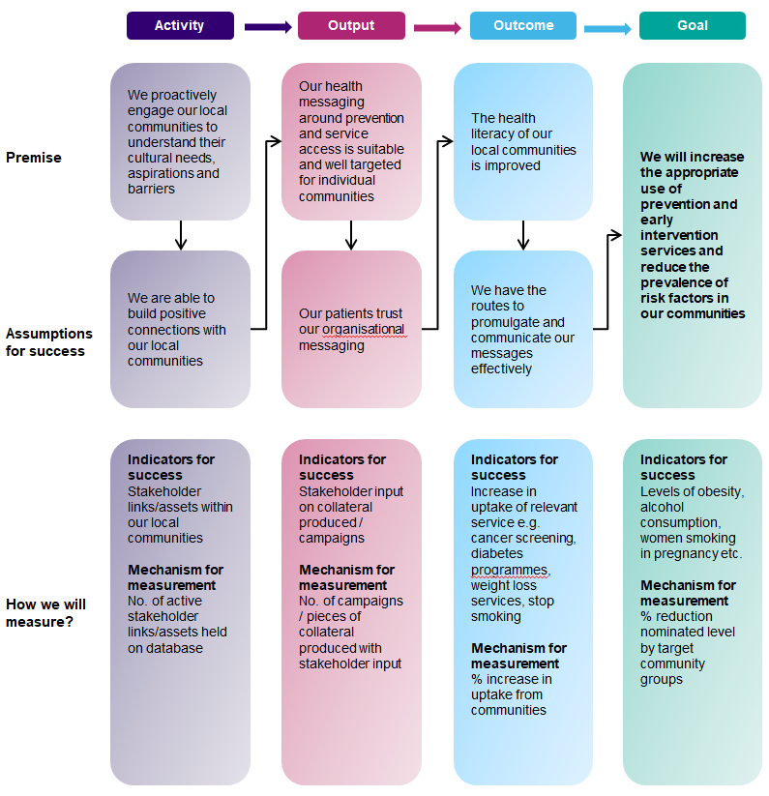
EXAMPLE: Reduce the prevalence of risk factors in our communities through improving our population’s health literacy

Appendix 4 – The Healthwatch Good Engagement Charter
1. We will be clear about why there is a need to engage with our community
The reasons for involving people must be clear from the start.
2. We will make sure that we work with partners when engaging with our community
People do not like being asked about the same thing over and over again. A joined-up approach is efficient and increases the likelihood of people taking part.
3. We will make sure there is plenty of time for engagement
We will give people plenty of time to give their opinions and will arrange events at different times so that more people can take part.
4. We will use a range of different ways for people to have their say
Some people like to talk in groups, while others prefer to complete an online survey or to tell one person their ideas. We will be inclusive and tailor our activities to the people we are hoping will take part.
5. We will be open, honest and transparent when engaging with our community
Agencies carrying out engagement activity should be open and honest about what can and cannot be influenced – including any constraints and boundaries – giving reasons for this.
6. We will make sure that information is accessible by all
Information needs to be accessible, clear, understandable, and relevant. It also needs to be presented in the correct format for the audience.
7. We will provide people with regular feedback when engaging with them
Results of engagement should be easily accessible to people who wish to view it – especially those people affected by the results of the consultation activity.
8. We will recognise best practice and make sure that it is used to inform future engagement with our community
Engagement that has worked well should be celebrated, shared between partners and also be used to develop future engagement activities.
9. We will evaluate the engagement process and make sure that any lessons learned are used to make engagement better in the future
Engagement will be reviewed to see how well it worked and if it has achieved what it set out to do. The process will also be assessed against the standards outlined in this charter.

[1] A carer is anyone, including children and adults who looks after a family member, partner or friend who needs help because of their illness, frailty, disability, a mental health problem or an addiction and cannot cope without their support. The care they give is unpaid. When we refer to carers in this document, this is inclusive of both adult and young carers.’ Reference NHS commissioning » Who is considered a carer? (england.nhs.uk)

